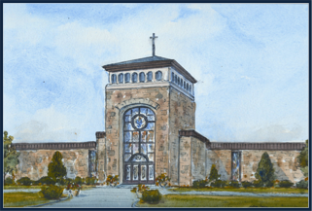
Letter to Msgr. Kinnally Requesting the
Sacrament of Confirmation or
An Interview with a Priest

Due By March 1, 2024

Before you receive the Sacrament of Confirmation, Msgr. Rob, our pastor, is required to testify to the Bishop Caggiano that you have been properly prepared and that you are freely and intentionally approaching this sacrament. He should have every confidence that you know what you are entering into and that you are ready to receive the grace that comes with Confirmation. To assist Msgr. Rob in meeting this requirement, we ask that you write a letter to him according to the outline below.

If you would prefer an interview with a priest, please see the instructions on the next page.

Your letter is to be submitted to your catechist or Mrs. Osterndorf
no later than March 1, 2024.

Instructions for preparing the letter:

- All letters should be typed on plain white paper.
- Include the date on which the letter was written at the top of the letter
- Begin with the greeting “Dear Msgr. Rob:”
- In the first sentence, request to receive the Sacrament of Confirmation.
- Then answer these two questions, writing 5 or 6 sentences for each question:
  - Talk about something you learned in class that will make you become a better Catholic Christian?
  - Choose one of the Seven Gifts of the Holy Spirit; define it; and tell Msgr. Rob how it will help you this year and in the future. Give a few examples.
- Close the letter by typing your full name and signing your name above that.

Thank you for taking the time to think and pray about your letter. I know Msgr. Rob reads every letter and is looking forward to reading yours!
Interview with a Priest

Interviews are designed to help you appreciate your growing relationship with Jesus. The priest will ask why you believe that you are ready to be confirmed. He will also answer any questions or concerns about Confirmation, or anything else about our Catholic Faith.

If you prefer to have an interview with a priest, instead of writing a letter, please ask your parent or catechist to email Mrs. Osterndorf before March 1, 2024.

============================================================
Please proofread your letter and check your spelling.

DON’T FORGET TO SIGN YOUR NAME.

Please contact Mrs. Osterndorf at 203-652-1173
or confirmation@starcc.com with any questions or to schedule your interview.

============================================================

