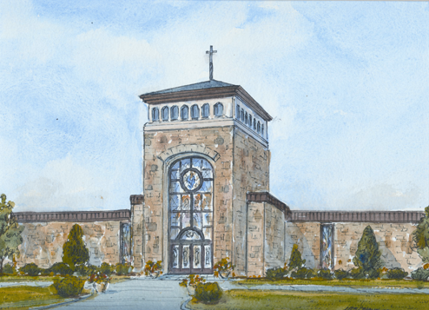
Confirmation Saint Report
St. Aloysius Parish
Confirmation Class of 2024

I have called you by name
One of your Confirmation requirements is to research a Saint and write a report on the Saint that you have selected. The report you write should be on the Saint whose name you have elected to take on as your Confirmation name. Reports are due to your catechist by December 1, 2023

“The saints lived on this earth and experienced suffering, joy, pain, broken promises, peace, frustration, war, injury, heart-break… they know our hearts. But mostly, they know what it takes to be united with God here on this messy earth. They know what it takes to live well for Him.”

Pick out a Saint to become your “prayer buddy” and your patron. Someone for you to pray to Jesus with, someone who is actually there in heaven with him! Get to know your saint. What were they like when they were your age? What made them a saint? Did they have a lot of brothers and sisters? In the fall you will need to write a one-page report about your saint.

“We choose a Confirmation saint (like we choose a Confirmation sponsor) not out of due diligence to the “rule,” but rather because we realize how unfortunate it would be to travel alone.”

Research:
Visit the Religious Education Offices and check out our saint books and resources
Look in your Chosen textbook for the Hero of the Week
· Saints “On-Line”:
Lifeteen’s Biggest and Best List of Confirmation Saints
http://www.officialcatholicdirectory.com/catholic-links/saints.html
www.catholic.org
www.americancatholic.org
REPORT – Due December 1st

· Write (print or type) a minimum of one page.
· Attach a cover page with
Saint’s name,
A picture of your Saint,
Your name and the date
Your catechist’s name
· The following questions will be helpful as you write your saint report
(You do not have to answer ALL of these questions!)
Why have you chosen this Saint?
Who is your Saint?
Where/when did you saint live?
What miracles are attributed to this saint?
Why was your Saint canonized?
What did this person do to become a saint?
How do you think this Saint will inspire you to lead a Catholic Christian Life?

Rachel Penate, Lifeteen, http://lifeteen.com/blog/biggest-best-list-confirmation-saints-guys-girls
Ibid

