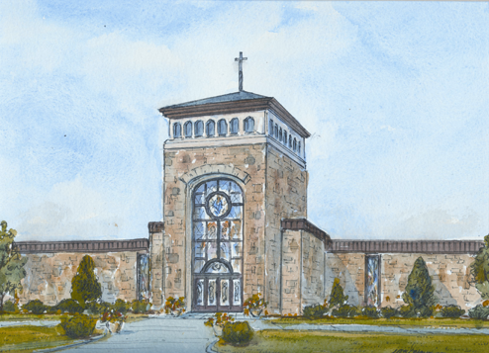
Confirmation Sponsor Form
St. Aloysius Parish
Confirmation Class of 2024
Class you are in: _______________________________________________________
Your First Name: ___________________ Your Last Name: ______________________
Confirmation Name (the Saint you are choosing): _______________________________
Sponsor: _____________________________________________________________
Sponsor’s Birthday (mm-dd-year): ____________ (Must be 16 years old by Confirmation)
Sponsor’s Mailing Address: ________________________________________________
City: ________________________________ State: _____________ Zip: _________
Sponsor’s Parish: _______________________________________________________
City & State of Sponsor’s Parish: ___________________________________________
I have asked the above person to be my sponsor because __________________________
.___________________________________________________________________
.___________________________________________________________________
Please return this form to your teacher when classes begin in the Fall; or send it to: Marie Osterndorf at St. Aloysius, 40 Maple Street, New Canaan, CT 06840. Please contact me if you have any questions! ALL ABOVE INFORMATION SHOULD BE FILLED IN. Remember if your sponsor is NOT from St. Aloysius, they must fill out a Sponsor Affirmation Form.

